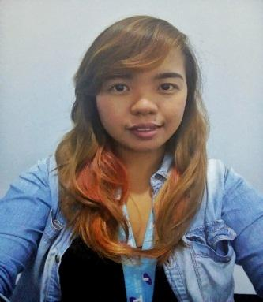

**YVONY APPLE R**. **OPADA**

6TH ST. BUENA HILLS GUADALUPE CEBU CITY

FEB.17,1992

27yrs. Old

[opadayvony17@gmail.com](mailto:opadayvony17@gmail.com)

0965.644.3256

Skype Id: live:.cid.9fd2bd35f7e8d53d

**SUMMARY OF QUALIFICATIONS**:

Almost four years of customer service and sales experience. Skilled in time management and ability to work with a team to achieve department objectives. Proficient in several computer software programs including MS Office applications.

**CUSTOMER SERVICE**:

* Develop effective call handling ethics to retain customer and continual positive feedback from customer
* Effectively serviced all customer inquiries in a timely manner
* Resolved customer demands and provide useful tips to avoid customers calling back
* Skilled and experiences in administrative task, email handling and clerical jobs.

**SALES**:

* Meet and exceeded department sales objective and goals through consistent sales efforts
* Consistently led sales in creating interest for customer to sign up to a new service
* Actively qualified and identified customers need to provide proper plans and solutions
* Coordinated with other sales team members to effectively service customer and meet department sales goals

**WORK EXPERIENCE:**

***TELSTRA POWERED BY TELETECH***

* RESIDENTIAL BILLING (UNIVERSAL) NOV. 2014 – SEPT. 2016
* VALUE HEALTH CHECK (SALES INBOUND) OCT.2016 – DEC.2016
* FOXTEL SALES, BILLING AND SAVES JAN. 2017 – JUL. 2018

**EDUCATION**

BACHELOR OF ELEM. EDUCATION

CEBU NORMAL UNIVERSITY GRADUATED MARCH 2012

BOARD PASSER LET FOR

TEACHERS SEPTEMBER 2012

**CHARACTER REFERENCES**

RYAN GEORGE GRANADOS SUPERVISOR FOXTEL 09218131378

ARLYN ENGALLA SME FOXTEL 09053682338

CHIQUE A. GAW COLLEGUE 09771463798